ENDS – Electronic Nicotine Delivery Systems

Act 580 of 2019 – Includes a change in legal age (now 21) for purchase of tobacco products in Arkansas - http://www.arkleg.state.ar.us/assembly/2019/2019R/Acts/Act580.pdf

Kansas Vape-Free Schools Toolkit – Arkansas version coming
http://www.kdheks.gov/tobacco/download/Vape_Free_Schools_Toolkit.pdf

Resources from the Arkansas Department of Health – Vaping Related
https://www.healthy.arkansas.gov/programs-services/topics/vaping-related-lung-illness

Centers for Disease Control – Data and Resources
https://www.cdc.gov/tobacco/basic_information/e-cigarettes/severe-lung-disease/resources/index.html
M.D. Anderson – ASPIRE (A Smoking Prevention Interactive Experience)
https://www.mdanderson.org/about-md-anderson/community-services/aspire.html

Arkansas Project Prevent
Create a 30-second video, which includes, but is not limited to, the following topics:
- Living tobacco-free and encouraging others to do the same.
- Educating others about the harmful effects of tobacco and nicotine, including e-cigarettes.
Deadline December 15, 2019
https://www.healthy.arkansas.gov/programs-services/topics/project-prevent-youth-coalition

Truth Initiative – Inspiring Tobacco Free Lives
https://truthinitiative.org

Inside Vaping video by Benji Jones https://www.businessinsider.com/vaping-how-bad-are-vapes-e-cigarettes-health-issues-deaths-2019-9?jwsource=cl

Talk with Your Teen About E-cigarettes: A Tip Sheet for Parents
https://e-cigarettes.surgeongeneral.gov/documents/SGR_ECig_ParentTipsheet_508.pdf

The Arkansas Opidemic

Arkansas Take Back
https://www.artakeback.org/opioid-education/arkansasopidemic/

Arkansas Take Back Naloxone
https://www.artakeback.org/take-back/naloxone/

Centers for Disease Control – Healthy Youth Resources
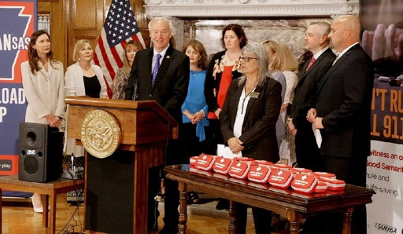
https://www.cdc.gov/healthyyouth/index.htm

Arkansas School Nurses Provided Naxolone
https://www.arkansasonline.com/news/2019/jun/26/program-to-put-naloxone-in-school-nurse-1/

Act 1222 of 2015 – "Good Samaritan" law
https://law.justia.com/codes/arkansas/2015/title-17/subtitle-3/chapter-95/subchapter-1/section-17-95-101/

Narkansas APP
https://www.artakeback.org/narcansas/

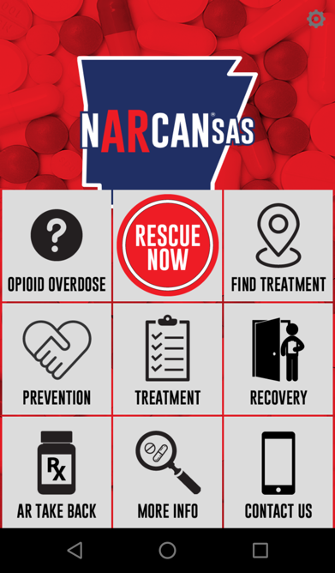
Available on:
Google Play and the Apple App Store

